

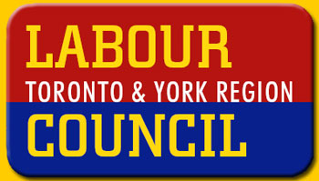

Union Counsellors Make a Difference
For Union Members
Living and/or Working in Toronto

Labour Community Services: A project of the Toronto and York Region Labour Council in partnership with the United Way of Greater Toronto

The Union Counsellor training provides you with:

- Information and referral skills

- Good listening, confidentiality and communication skills
- Union and Community services
The Union Counsellor offers the following services:

- Helps members over and above what is provided in the Collective Agreement

- Links members when they face personal and family problems with appropriate resources

The Union Counsellor Level One Program will equip you with the tools you need to get your members the help they need.

Topics Covered:
Session I - Unions & Communities Working Together
Session II - Your Community Services
Session III - Interviewing & Referral Skills
Session IV - Principles of Communication
Session V - Stress
Session VI - Addiction & Dependency
Session VII - Understanding Violence
Session V111 - Family Law
Session 1X - Tenant Issues
Session X - Union Counselling & Equity
Session X1 - Implementing/Strengthening A U.C. Program

turn over …

Register NOW for the
Union Counsellor Program!

Dates: Tuesday, March 3 to Tuesday, May 12 2009

Time: 1 Evening a Week - 6:00 pm to 8:30 pm

Place: Ontario Federation of Labour
15 Gervais Drive, Toronto
(1 block east of Don Mills, north side of Eglinton)

Cost: $165.00 (includes the Directory of Community Services in Toronto,
also known as the Blue Book), plus all Resource Materials

Toronto - Registration Form

Name of Participant:
Address:
City: Postal Code:
Work Phone: Home Phone:
E-mail: Fax:
Union: Local:

Invoice Issued to:
Name:
Mailing Address:

To register, fill in the above information and:
Fax this form to 416.445.5146
OR mail your registration fee and form to:
Labour Community Services
15 Gervais Drive, Suite 603, Toronto, ON M3C 1Y8

Local will be invoiced and cheque should be made payable to Labour Community Services

For more information contact Felicia Houtman
Phone: 416.445.5819 Ext. 26
E-mail: fhoutman@labourcommunityservices.ca

usw-L.8300

